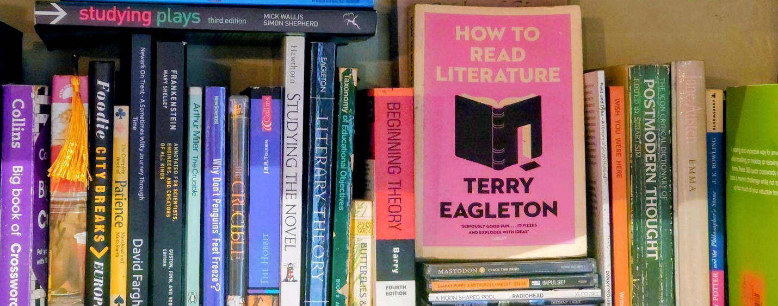

Curriculum Map for Literature

Credits and Copyright
© 2026 DisciplineOfEnglish.co.uk
All rights reserved.
This document, Discipline of Literature / Student Workbook, has been authored as part of a structured curriculum framework for the teaching of literature, to supplement lessons from the DisciplineOfEnglish.co.uk website. The intellectual content, lesson sequencing, selection of academic terminology, and methodological explanations contained within this document are the original work of Aaron Swan, produced for educational use within DisciplineOfEnglish.co.uk.
No part of this document may be reproduced, stored, transmitted, adapted, or distributed in any form or by any means without prior written permission, except where permitted for internal educational use within the originating institution.
This document is intended for professional teaching and curriculum design purposes only. It is not a substitute for statutory guidance, awarding-body specifications, or examination materials.

1XX Factual Knowledge

10X Defining Characteristics

Lesson 101: What Are We Actually Doing When We Write About Literature?

Lesson 102: Fiction and Non Fiction

Lesson 103: How Do Texts Get Their Meanings? Encoding & Decoding in Literature

Lesson 104: Who Decides What a Text Means? Authorized and Unauthorized Readings

Lesson 105: Who Is the Text Written For? The Ideal Reader

Lesson 106: Where Do Stories Come From? Ur-Forms and Intertextuality

Lesson 107: Why Do Texts Contain Many Meanings at Once? Literature as a Reflection of Its Era

Lesson 108: Why Do Some Texts Keep Getting Taught?

Lesson 109: How Do Texts Get Grouped and Why? Genre, Form, and Function

11X Early English

Lesson 111: How Did the Earliest English Texts Create Meaning? Early English: Heroism, Elegy, and Oral Tradition

Lesson 112: How Did Stories Survive Before Books? Mnemonics, Orality, and Memory in Early English

Lesson 113: How Did Early Literature Learn to Measure the World? Computus, Order, and Meaning in Early English

Lesson 114: Why Does Magic Appear in Early Literature? Folklore, Charms, and Magical Power as Sign Systems

Lesson 122: How Did Print Become the Authority for Culture? The Reformation, Control of Books, and the Rise of Print Power

Lesson 123: Why Do Stories Focus on Knights, Honour, and Moral Tests? Romance and Chivalric Action in the Premodern Era

13X Modern English

Lesson 131: How Did Modern Literature Begin to Trust Human Reason? Natural Philosophy, Scientific Enquiry, Free Will, and Human Potential

Lesson 132: How Did Humans Become the Measure of Meaning? Enlightenment Thinking and the Emergence of Man

Lesson 133: Why Did Writers Turn Inwards? Sensibility, Self-Awareness, and the Romantic Imagination

Lesson 134: Why Did the Novel Emerge in Modernity? The Novel as a Modern Literary Form

14X Postmodern English

Lesson 141: Why Did Writers Stop Trusting Big Explanations? Postmodernism and Incredulity Toward Grand Narratives

2XX Conceptual Knowledge

21X Dramatic Appeal

211 The literary form

212 Literariness: Todorov’s Narrative Structure

213 Literariness: Archetypal Characters

22X Ideology and Political Readings

221 Ideology & Politics: Feudalism, Monarchy, Republic, Democracy

222: Ideology: Left-Wing and Right-Wing Politics

223: Ideology: Class, Citizens, and Social Structures

23X Human Nature:

231: Motivation & Desires (Freud, Lacan, Repression)

232: Range & Intensity of Emotions (Plutchik)

233: Maslow’s Hierarchy of Needs

24X Structuralism:

241: Binary Opposition & Meaning Within the Text

242: Structuralism Beyond the Text: Cultural Codes & Systems

243: Post-Structuralism: Unstable Meaning & Deconstruction

25X Representation:

251: Representation & Misrepresentation

252: Representation of Dominant Narratives: Absence, Abject, Parody

253: Representation of Subaltern, Exoticism, Eurocentrism

3XX Procedural Knowledge

301 Procedures of Tradition

302 Procedures of Formalism

304 Procedures of Poststructuralism

4XX Metacognitive knowledge

End

