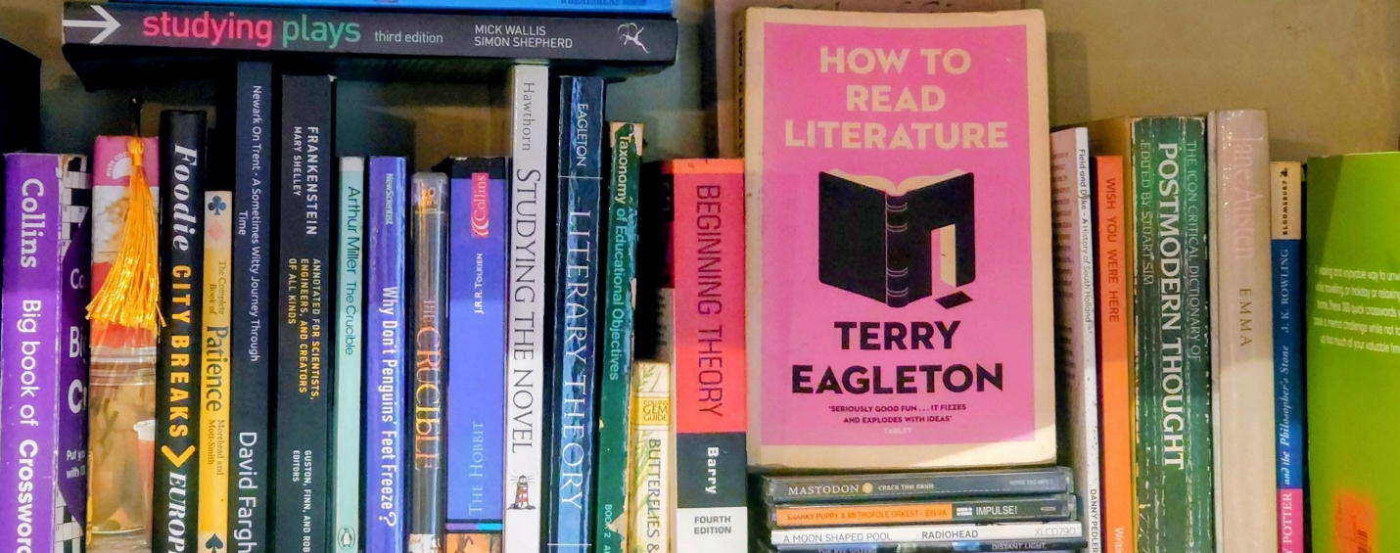

Glossary of terms for Literature

Credits and Copyright
© 2026 DisciplineOfEnglish.co.uk
All rights reserved.
This document, Glossary of terms for Literature, has been authored as part of a structured curriculum framework for the teaching of literature, to supplement lessons from the DisciplineOfEnglish.co.uk website. The intellectual content, lesson sequencing, selection of academic terminology, and methodological explanations contained within this document are the original work of Aaron Swan, produced for educational use within DisciplineOfEnglish.co.uk.
No part of this document may be reproduced, stored, transmitted, adapted, or distributed in any form or by any means without prior written permission, except where permitted for internal educational use within the originating institution.
This document is intended for professional teaching and curriculum design purposes only. It is not a substitute for statutory guidance, awarding-body specifications, or examination materials.

Alphabetical Glossary – Literature Methodological Strand

Abject
Represented as monstrous, repellent, or threatening in order to justify fear, exclusion, or oppression.

Aesthetic Experience
The emotional or intellectual effect a text creates for a reader.

Aesthetic Reading
Reading to experience emotion, tone, mood, and the lived experience of a text.

Allegory
A story where characters and events represent moral, spiritual, or ideological ideas rather than literal realities.

Alliteration
The repetition of starting sounds in words, used to aid memory and reinforce meaning.

Amelioration
A form of representation that makes something appear more positive or favourable than reality.

Antagonist
A character or force that opposes the protagonist.

Archetype
A recurring character type or narrative role that performs a familiar function in stories.

Authorised Reading
An interpretation supported by textual evidence and shared methods of literary understanding.

Bias
An author’s perspective or viewpoint that shapes how reality is represented in a text.

Binary Opposition
A pair of opposite ideas (such as order/chaos or good/evil) that create meaning through contrast.

Canon / Canonical
Texts that are valued, preserved, and repeatedly taught over time.

Charm
Words or actions believed to carry magical or supernatural power in folklore traditions.

Chivalry
A moral and spiritual code guiding knightly behaviour, emphasising honour, loyalty, restraint, and virtue.

Citizenship
Belonging within a society, including rights, responsibilities, and recognition, often experienced unevenly.

Class
A social group defined by wealth, status, education, and access to power.

Computus
A system for calculating time, seasons, and cosmic order, shaping early literary views of fate and nature.

Condensation
The fusing of multiple desires, meanings, or emotions into a single image or symbol.

Containment
When a text supports, reinforces, or upholds a dominant ideology.

Convention
A shared rule, pattern, or expectation readers learn to recognise in literature.

Cultural Code
A shared system of meaning outside the text that readers use to understand signs.

Cultural Dialogue
An ongoing conversation across generations about ideas, values, and human experience.

Cultural Knowledge
Shared beliefs, meanings, and understandings learned within a society.

Decode
The process by which readers interpret meaning using learned knowledge.

Deconstruction
A process of revealing instability, contradiction, and slippage in meaning.

Difference
The principle that meaning is produced through contrast rather than isolation.

Displacement
Redirecting emotions from their original cause onto a safer target.

Disruption
An event that breaks narrative equilibrium and creates tension.

Doctrine
Official religious teaching that authorises understanding in premodern belief systems.

Dominant Narrative
The main ideological story promoted and protected by those in power.

Dyads
Blended emotions formed from combinations of primary emotions.

Early English
A literary era shaped by fate, exile, heroism, warrior culture, and instability.

Efferent Reading
Reading to extract information, facts, or knowledge about the world.

Elegiac
Expressing loss, mourning, grief, or longing.

Encode
The way writers build meaning into texts using signs.

Enlightenment
A movement emphasising reason, evidence, judgement, and human responsibility.

Equilibrium (Narrative)
A state of balance or normality at the beginning of a story.

Eurocentrism
Treating European culture as superior and positioning other cultures as deficient or marginal.

Exile
Separation from home or community, often associated with loss and suffering.

Exoticism
Portraying cultures as strange, thrilling, or spectacle-like for consumption.

Exclusion
The elements of reality left out of a representation.

Fate
The belief that life is controlled by forces beyond human choice.

Feudalism
A hierarchical system based on land, loyalty, and service.

Fiction
Elements invented or created by the author.

Foil
A character designed to highlight another character through contrast.

Folklore
Traditional beliefs, customs, and stories passed down orally.

Form
How a text is structured or shaped.

Free Will
The capacity for humans to make choices and be held responsible.

Function
What a text or genre is designed to do for readers.

Genre
A group of texts that share forms and functions.

Grand Narrative
A total explanation claiming to explain all of society or history.

Heroic Ethos
Values of bravery, loyalty, honour, and reputation in warrior cultures.

Historical Sign System
A set of meanings shared by a particular culture or era.

Humanism
A belief in human value, reason, and potential.

Human Potential
The capabilities humans have to grow, choose, and create meaning.

Ideal Reader
The type of reader a text is designed for, who understands its signs and conventions.

Id
The part of the psyche driven by instinct and desire for pleasure.

Ideology
A system of beliefs about how society should function and distribute power.

Incredulity
Scepticism or disbelief toward grand narratives.

Instability
The idea that meaning shifts and is never fully fixed.

Intertextuality
The network of connections between texts that shape meaning.

Interpretation
An explanation of what a text means.

Maslow’s Hierarchy of Needs
A psychological model describing human needs from survival to fulfilment.

Material
The text itself: characters, events, and language.

Material Knowledge
Knowledge of what happens in the text.

Method
A shared way of thinking used to explain how literature works.

Methodological Knowledge
Knowledge of literary systems, conventions, and meaning-making processes.

Mnemonic
A device designed to help memory.

Misrepresentation
A distorted depiction created through selection, bias, or exclusion.

Monarchy
A system of rule led by a king or queen.

Modernity
A period emphasising reason, science, free will, and responsibility.

Narrative Equilibrium
The opening balance of a story’s world.

Natural Philosophy
Early scientific thinking about the natural world.

New Equilibrium
The altered state at the end of a narrative.

Non-Fiction
Elements that reflect real events, people, or situations.

Novel
A long prose narrative focused on individual experience and social reality.

Oral Culture
A culture that preserves stories through speaking rather than writing.

Pagan
Pre-Christian belief systems.

Paradox
Two opposing ideas held together to create deeper meaning.

Parodic
Represented through mockery or ridicule.

Pathos
Language designed to evoke emotional sympathy.

Pejoration
A representation that makes something appear more negative.

Postmodernity
A period sceptical of stable truth and grand explanations.

Primary Emotions
Basic human emotions such as fear, joy, and anger.

Print Authority
Power gained through controlling printed texts.

Prose
Everyday written language, not verse.

Protagonist
The central character whose journey shapes the narrative.

Prosody
The rhythm and sound patterns of language.

Reformation
A period of religious and political change reshaping belief and print.

Realism
Representing everyday life accurately.

Recognition (Narrative)
The moment characters realise a problem exists.

Repression
Forcing unwanted thoughts or desires out of awareness.

Republic
A system of government led by elected representatives.

Representation
A constructed version of reality in a text.

Romance
Medieval narratives focused on moral testing and virtue.

Romanticism
A movement emphasising emotion, imagination, and inner life.

Scientific Enquiry
Testing ideas through observation and evidence.

Selection
What an author chooses to include.

Self-Actualisation
The fulfilment of personal potential and autonomy.

Sensibility
Emotional awareness as a source of understanding.

Sign
Anything that carries meaning beyond itself.

Social Stratification
The hierarchical layering of society.

Subaltern
Groups pushed to the margins and denied voice or power.

Substrata
Layers of older meanings beneath newer ones.

Subversion
When a text challenges dominant ideology.

Superego
The internalised voice of rules and morality.

Synthesis
Combining material knowledge with methodological knowledge.
Theme
The overall conceptual idea being grappled with, such as: Our human nature; Dramatic appeal; Our political structures; The inter-relatedness of meaning; Issues of representation.

Tradition
Repeated literary forms, patterns, and ideas over time.

Unauthorised Reading
An interpretation not supported by the text or shared methods.

Ur-Form
The imagined idea of a single original story.

Value
What a society decides matters and preserves.

Virtual Witness
Experiencing events through narrative without being present.

Virtue
Moral goodness demonstrated through behaviour.

