Delivery date: | Ie: academic year | Delivery Timeslot: | Ie: periods
Teacher Present: | Ie: staffing | Teacher Absent:
Head Of Dept: |  | Teaching Assistant: | Ie: staffing
Class Code: |  | Ability range:

Learning Objectives: | Mission Statement: Prioritising of the Methodological Learning – this is mandatory to the discipline and transferable to future units. Future units will be recalling and strengthening methodological knowledge through repetition.

Disciplines Across The Duration Of Enrolment:
The six ‘half’ terms match the number of courses delivered across Language and Literature. By assigning each term a course, year groups are aligned in learning objectives / genres. Literature does pressurise the delivery to fit a text and the methodological learning into a single half term, but all lessons are given over to this one unit (alternatively, Literature and Language cover two half terms but consume half the timetabled lessons). This ultimately reduces cognitive load on the teacher, as the learning objectives and style of application are the same across different year groups.
The syllabus of the discipline will indicate how to fit the curriculum (learning objectives) into the time allocated.
Example Year | Terms across a year
Term | 1 | 2 | 3 | 4 | 5 | 6
Discipline | Language 01 | Lit Heritage | Lit Poetry | Language 02 | Lit Modern N | Lit Shakesp
Year 7
Year 8
Year 9
Year 10
Year 11 | Priority 1 | Priority 2 | Priority 3 | Practise Papers
This sequence means that the Methodological Knowledge of Literature is delivered 4terms x 3years; 12 occasions. As the learning objectives do not change from text to text, they are being recalled up to 12 times, reinforcing the use of long term memory.
The themes should be set to appropriate terms – poetry might be most appropriate unit for the shortest term. Longer heritage texts, or Shakespeare set for the longest terms.
Example Unit | Weeks in a term:
Lesson: | 1 | 2 | 3 | 4 | 5 | 6
1
2 |  |  |  |  |  | Prep
3 |  |  |  |  |  | Assess
4

The principal unit (Either Language or Literature) which equates to roughly 18 lessons per term.
Literacy (often held in the library – note that literacy has its own unique curriculum)

Principle Unit
The main unit will have roughly 18 lessons in a term. The teacher will be responsible for selecting the discrete packets of knowledge in the curriculum and delivering roughly 15 of these, and recording the success of the student in handling each LO.
Classes should not be overloaded by giving 15 different LOs in each term, and LOs that have not been met should be covered in subsequent terms to ensure that knowledge is being reinforced.
Where classes are failing in more LOs than they are succeeding, the priority needs to be in repeating LOs and not delivering new LOs. Secure knowledge of a few is more preferable to an insecure knowledge of many.
A record needs to be kept of what LOs have been delivered and the overall success of the pupils in each LO.

Tracking, intervention and assessment
A detailed tracking document would require a table of Units and LOs, printed for each student. A red/amber/green indicator for each student would indicate the degree of security in each LO. The student average can then indicate the general student performance. It would be difficult to then coordinate 30 odd sheets to establish a class average and so this would best be ascertained through end of term assessments.
Choices about what the department is willing or able to do need agreeing. Individual student trackers can be very useful to future teachers to see what LOs need to be revisited. When classes' sheets are gathered together, a teacher can gauge the ability range and plan accordingly.
When an LO has not been well met, a discrete objective can be delivered during intervention to correct the learning of the student. Without discrete learning objectives (as opposed to assessment objectives), it can be difficult to know what exactly to teach to the student.
The assessment Objectives then become the measure of how well the learning is being incorporated into outcomes. We are not reporting back that a student needs to improve in a particular AO, but what LOs would help the student to advance.
Modern Novel 8En2 | Weeks in a term:
Lesson: | 1 | 2 | 3 | 4 | 5 | 6
1 | Lit 101 | Lit 104 | Lit 107 | Lit 112 | Lit 123 | Lit 211
2 | Lit 102 | Lit 105 | Lit 108 | Lit 113 | Lit 131 | Prep
3 | Lit 103 | Lit 106 | Lit 110 | Lit 121 | Lit 133 | Assess
4

In this example tracking table, the class’ general performance has been tracked (though this could be replicated for every individual student, and the class average calculated – this per-student tracking would be highly accurate but have a very high work load). Green indicates that the class performed well, orange that som students struggled, red that many students struggled.
The impact of this tracking is that green objectives might not need covering again, orange and red will. So the next unit could start at Lit 110 and proceed from there. In this way, progress is being made through the learning objectives, and those that were not deemed a success are repeated. Green objectives are ‘bagged’, and still relevant to assessments.
Modern Novel 8En2 | Weeks in a term:
Lesson: | 1 | 2 | 3 | 4 | 5 | 6
1 | Lit 110 | Lit 123 | Lit 211 | Lit 221 | Lit 231 | Lit 241
2 | Lit 113 | Lit 131 | Lit 212 | Lit 222 | Lit 232 | Prep
3 | Lit 1221 | Lit 133 | Lit 213 | Lit 223 | Lit 233 | Assess
4

In this example, only the latter lessons were flagged as orange, but the assessment was also flagged as orange. This suggests that whilst the class might have felt to have progressed well, this was not borne out in attainment. It might be that the assessment itself was too difficult.

Literacy
Literacy discipline is an ongoing project of skill development and reading engagement. The general guidance is as follows:
- To be held in the library.
- Teachers to assess reading ages of students and assign bookmarks;
  - Book marks contain student name and reading ranges to help identify suitable literature,
  - check books are ability appropriate,
  - Track the number of pages being read at home in reading bookmarks.
- Identify the need of individuals and ensure students are working on their specific development need from the following:
  - Reading / decoding,
  - Comprehension / recall,
  - Handwriting.
- Track and intervene with individuals and monitor progress.
- Students can be grouped into intervention strategy to develop together.

Assessment: Understanding the Conceptual Challenge
Assessing students at Key Stage 3 presents a persistent conceptual difficulty: schools often attempt to answer several different questions with a single grade. At various points, assessment is expected to describe a student’s current performance, indicate the progress they have made over time, and predict whether they are “on track” for a future GCSE grade. These aims are not interchangeable, yet they are frequently collapsed into one system, creating confusion for teachers, students, and parents.
A central tension lies in whether KS3 assessment should be criteria-referenced or trajectory-based. A criteria-referenced approach evaluates what a student can do in relation to clearly defined disciplinary expectations. This model focuses on the curriculum: the knowledge, concepts, and procedures students have been taught and can demonstrate. It allows teachers to make valid statements about attainment because it is anchored in what has actually been learned. In contrast, trajectory-based systems—often called “flight paths”—attempt to map a student’s current performance onto a predicted GCSE outcome. These systems typically rely on KS2 prior attainment and assume linear progress across five years. While administratively convenient, they risk reducing assessment to a form of prediction rather than a reflection of learning, and they can encourage teachers to mark work according to where a student is “supposed” to be rather than what the work shows.
Another source of conceptual difficulty is the use of target grades and cohort comparisons as measures of success. Target grades, derived from KS2 data, can create the impression that a student’s potential is fixed and measurable at age eleven. When used as the primary reference point, they shift attention away from the curriculum and towards compliance with a projected pathway. Cohort comparisons, meanwhile, can be useful for moderation and standardisation, but they are norm-referenced rather than curriculum-referenced: they tell us how a student performs relative to peers, not what they know or can do. Neither approach, on its own, provides a secure basis for understanding learning.
Schools therefore face a choice between several models of grading. Pure criteria-referenced assessment is the most conceptually robust, as it aligns directly with the taught curriculum and disciplinary constructs. Mastery bands offer a simplified version of this approach, though they can drift into pseudo-flight paths if not carefully managed. Standardised tests provide reliable comparative data but capture only a narrow slice of the curriculum. Mixed models—criteria-based judgments moderated across the cohort—can balance validity and reliability but require strong professional agreement about standards. Flight-path models remain the least defensible at KS3 because they prioritise prediction over learning.
To measure attainment meaningfully, teachers must focus on what students can demonstrate now, using clear, discipline-specific criteria. To measure progress meaningfully, schools must track how far students have moved through a well-sequenced curriculum, comparing their current performance to their own prior performance rather than to a predicted GCSE grade. Progress is therefore a curriculum construct, not a statistical one.
When grading, departments need to make clear:
- Does this grade reflect what a student could achieve at terminal exams? – or -
- Does this grade reflect the quality of learning from the lesson? – or –
- Does this grade link the student to ex students, and what they went on to achieve based on the same standard, during this same modules

Key Stage 4:
By keeping the same text themes as KS3, teacher cognitive load continues to be benefitted.
 | Themes by term
Year 10 | Language 01 | Lit Heritage | Lit Poetry | Language 02 | Lit Modern N | Lit Shakesp
Year 11 | Mocks | Focus 1 | Focus 2 | Focus 3 | Exams
Importantly, for KS4 the priority changes and the text is mandatory. Students need to be using their recall skills to draw the methodological knowledge. This knowledge is now the key to unlocking their academic analysis of set exam texts.
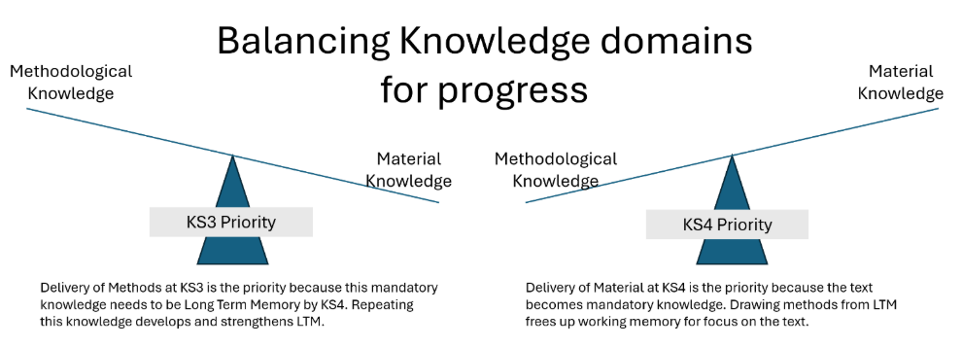
Students need to build detailed knowledge of their key exam texts to which the methodological knowledge is being applied. Although this was practised at Key Stage 3, using extracts as representative of longer texts, now the focus is on learning the full text. The pedagogy tells us that knowledge drawn from Long Term Memory has negligible impact on cognitive load. Students should be using recall strategies to draw methodological knowledge (which was the focus on KS3 learning) from LTM. Recall strategies can include:
- An external memory domain (posters, mind maps, scaffolds etc)
- Glossary of terms
- Recall of key extracts and how terms were applied in KS3
Departments will often extend the duration of a unit across multiple terms to give more time over to studying a text in full, leaving almost no revision time prior to exams. School planning for mock exams also direct what can and can’t be done with the English curriculum. Given this, the actual suggested timetable above will either be adapted, or the mock exam papers will need to be adapted to reflect what has been covered.
Once reliable data is obtained, a set of foci need establishing to revise from. These priorities fill the remaining terms, including past papers. Priorities could be:
- Progress and attainment related to a particular text,
- Progress and attainment related to particular Learning Objectives,
- Progress and attainment in the essay style and analytical framing.

