Delivery date: | Ie: academic year | Delivery Timeslot: | Ie: periods
Teacher Present: | Ie: staffing | Teacher Absent:
Head Of Dept: |  | Teaching Assistant: | Ie: staffing
Class Code: |  | Ability range:

Mission statements need to be underpinned by the academic, pedagogical, theoretical framework around teaching. The selection of academics here prioritize ideas of cognitive load, sequencing, distinction between knowledge forms, the prioritizing of knowledge forms and the range of knowledge within a discipline. The subsequent curriculum and lesson designs have been built in response to these.

Disciplines within English:
DisciplineOfEnglish.co.uk delineates different disciplines – it treats each as a distinct body of knowledge and intends to keep a strict boundary between these.
- Literacy could be considered a skill of reading, writing and speaking developed mostly through focused practise and rehearsal - not a body of knowledge.
- Language is concerned with a body of knowledge rather than skill; the grammatical rules that govern communication.
- Literature is concerned with a body of knowledge rather than skills; the symbolic ambiguity that create debate and friction between readers.
- Creative Writing - though this sub discipline is not currently a module within DisciplineOfEnglish.co.uk, it should be recognised that it does contain a body of knowledge distinct from that of Language and Literature. We might often think of the GCSE Language Section B question as a 'creative writing' activity, but that is better thought of as a question in which you demonstrate control over grammar and form. We often use Literature as stimulus for writing, but this is a distraction from the core body of knowledge contained in Literature - creative writing can be an engagement task but not a learning outcome.
- Media forms - ironically, Literature and Language articles are a subset within Media. Literature and articles are media forms, though digital media is chronologically newer than Literature. Media as a term simply means 'medium' through which we communicate.

The Virtual Department:
This website intends to provide the materials a full working department would need. In this manner, it can be relied upon to stand alongside a physical department.
The learning in each discipline is designed with a mission statement (long term pedagogy), syllabus (sequencing), curriculum (learning objectives) and lesson plan (point-of-contact). The curriculum follows upon Anderson and Krathwohl's delineations of knowledge; factual knowledge, conceptual knowledge, procedural knowledge and metacognitive knowledge.
Because the virtual department is not connected to any one exam board, students still need specific teaching and learning to align with the expectations of their final exams.

Pedagogies being followed

In summary
- Knowledge can be distinguished between the methodological (substantive / disciplinary knowledge) and the material (textual knowledge).
- The methodological knowledge is powerful, transferable and universal across a discipline – it is mandatory to the learning. The material is arbitrary and is there to evidence the efficacy of the methodological knowledge.
- Students will struggle when both kinds of knowledge are new, and will be supported when at least one of these is being drawn from long term memory.
- Knowledge in long term memory has significantly less impact on cognitive load than new knowledge being used in working memory.
- Prioritising the learning of methodological learning and passing this into long memory eases cognitive load when material study is challenging.
- Placing disciplinary knowledge into long term memory is a necessary part in reducing the cognitive load of cognitive studies because to do so frees up working memory for the text.
- The Methodological Knowledge needs sequenced and revisited to pass into long term memory. By repeating the methodological lessons for all Literature syllabi, learning is being reinforced and strengthened. The textual knowledge at lower levels does not need passing into long term memory and is not sequenced for later retrieval.
- At higher years, the exam texts are the priority in knowledge. GCSE can be described as having mandatory knowledge in both methodological and material forms, but having methodological in LTM allows working memory to focus on the material – thus the sequencing resolves a long standing problem of how to deliver Literature.
- Without this conceptual language being taught explicitly, students are unable to even conceive of the information, and so withholding conceptual language leaves students deficient in even the ability to conceive of analytical processes. Thus, to actually understand texts in a disciplinary way, the disciplinary language needs teaching first.
- Pace through learning objectives needs to lead to a success of 85%.
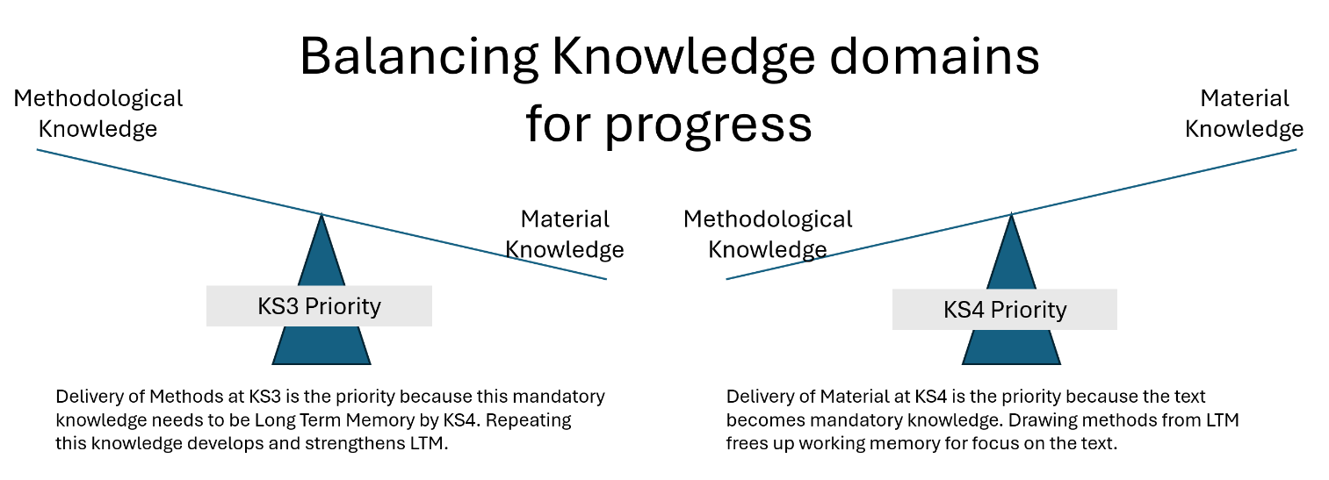

Gestalt Theory and Holistic Pedagogy
Gestalt theory and holistic pedagogy support Discipline of English’s commitment to presenting a disciplinary construct as a coherent whole before analysing its constituent parts. Gestalt theory proposes that meaning arises from the relationships among elements, so the whole cannot be understood simply by accumulating isolated details. In education, a holistic approach therefore gives learners an initial view of the complete text, concept, process, or discipline, enabling them to recognise its purpose, pattern, and organising principles before attending to granular features. DoE applies this principle by establishing whole texts in completion first, rather than passages or extracts for detailed analysis which accrue to a whole construct, In practise, this means being exposed to whole texts before analysis in undertaken. This often requires adapted versions of large texts to ensure that study is brisk. Detailed study is not displaced but made more meaningful: each part is taught in relation to the larger construct, and learners repeatedly return to the whole with increasingly precise understanding. This whole-to-part movement helps prevent fragmented knowledge and supports students in seeing how individual choices and concepts contribute to an integrated literary interpretation.

Benjamin Bloom, Cognitive Domain
Benjamin Bloom’s taxonomy informs Discipline OF English’s distinction between material and methodological knowledge within literary study. Bloom conceptualises the cognitive domain as progressing from the acquisition of knowledge to increasingly complex ways of working with that knowledge. The lower levels of cognition—knowledge and comprehension—concern material knowledge: the secure understanding of texts, concepts, terminology, and contextual information. Higher cognitive processes—application, analysis, synthesis, and evaluation—constitute methodological knowledge: the disciplined methods through which learners interpret, critique, and generate meaning. DoE adopts this structure by recognising that critical analysis is not a generic skill but a method dependent upon secure literary knowledge. Students are therefore taught substantive content explicitly to be able to analyse, evaluate, or create interpretations. In aligning Bloom’s distinction between the material and the methodological knowledge, DoE ensures that analytical sophistication emerges from knowledge mastery, allowing literary criticism to be both cognitively rigorous and intellectually authentic.

Joseph Sweller, Cognitive Load Theory
Joseph Sweller’s Cognitive Load Theory underpins Discipline of English’s commitment to purposeful, knowledge-rich literature instruction. Sweller demonstrates that learning is constrained by the limited capacity of working memory and that instruction must be carefully designed to avoid cognitive overload. Sweller explains how drawing knowledge form Long Term Memory significantly eases the cognitive load, but learning needs to be carefully sequence so that the knowledge needs of future units have been passed into LTM earlier in the learning sequence.
DoE applies this principle by making distinct the Methodoloical Knowledge and the Material Knowledge as two separate forms of cognitive load. When both are high, students are less able to make sense of the learning, and inhibited from passing this learning to LTM. At higher levels of education, both of these can be considered mandatory knowledge forms, and so having one stored in LTM for recall is essential to ease cognitive load. The choice in effect then, should the higher ed. material or methodological knowledge be studied in lower education?
To answer this, we should recognise when material is arbitrary and when it is mandatory. At lower levels of education, the text is effectively arbitrary; it doesn’t matter whether the text being studied is a poem, a novel, a play, a diary, so long as that text is a good example of the methodological principles. This means that the methodological knowledge should be prioritised, repeated and recalled, so that that when the material text of higher education is mandatory, those disciplinary principles are being drawn from long term memory.
This sequence of methodological learning first, material second, is how DoE engages with Sweller’s recommendations.

Hirsch, Knowledge Rich Curriculum
E. D. Hirsch Jr.’s work provides a foundational justification for DoE commitment to a knowledge-rich literature curriculum. Hirsch argues that reading comprehension and critical thought are not transferable skills but are dependent on shared, sequenced background knowledge stored in long-term memory. Through works such as Cultural Literacy and Why Knowledge Matters, he demonstrates that students struggle not because they lack strategies, but because they lack the cultural, historical, and conceptual knowledge that texts assume. DoE reflects this insight by treating disciplinary knowledge as essential rather than incidental: concepts, and contexts are deliberately selected and cumulatively taught. This approach supports intellectual equity by ensuring that all students, regardless of background, gain access to the shared knowledge required for deep literary understanding. In aligning knowledge acquisition with critical analysis, DoE positions literary study as both intellectually rigorous and socially enabling.

Michael Young; Powerful Knowledge
Michael Young’s concept of powerful knowledge clarifies why Discipline of English distinguishes between arbitrary and mandatory knowledge within the literature curriculum. Young argues that schools exist to provide access to specialised, systematic knowledge that takes learners beyond everyday experience. Mandatory knowledge consists of concepts, frameworks, and disciplinary structures that are transferable across units of work because they are rooted in the internal logic of the subject itself. In contrast, arbitrary knowledge—such as isolated activities, themes, or text-specific tasks—has limited power beyond its immediate context. DoE prioritises mandatory literary knowledge because it enables cumulative understanding: concepts such as genre, narrative form, rhetoric, and critical perspective recur across texts and units, allowing students to think with increasing abstraction and authority. This gives mandatory knowledge a necessary sequential priority, as later analytical work depends upon earlier conceptual mastery. In aligning with Young’s entitlement to powerful knowledge, DoE ensures that literary study is coherent, cumulative, and intellectually emancipatory rather than episodic or experience-led.

Paul Kirschner; Why Minimal Guidance During Instruction Does Not Work
Paul Kirschner’s critique of minimal guidance challenges the assumption that learners acquire knowledge most effectively through discovery. In Why Minimal Guidance During Instruction Does Not Work, Kirschner argues that unguided and discovery-based approaches are misaligned with human cognitive architecture. Learning, he explains, requires durable changes in long-term memory, yet discovery learning places excessive demands on limited working memory by forcing novices to search for solutions before they possess the necessary schemas. This problem-solving search may lead to task completion without learning, as cognitive effort is expended on procedures rather than understanding. Kirschner demonstrates that guided instruction—through explicit explanation, modelling, and structured practice—supports schema formation and reduces extraneous cognitive load. Only once learners have sufficient prior knowledge does guidance become less necessary. His work therefore establishes that facilitative teaching must be grounded in explicit instruction, ensuring that exploration follows knowledge acquisition rather than replacing it.
Paul Kirschner’s work is often misunderstood as an argument against facilitation. In fact, his position is that effective facilitation is only possible once learners have been given explicit instructional guidance. His support for facilitative learning is therefore conditional, developmental, and cognitively grounded, rather than ideological.
Kirschner argues that learning is defined as a change in long-term memory, and that novices lack the schemas needed to guide their own inquiry. When learners are asked to discover content with minimal guidance, they must rely on limited working memory, leading to inefficient problem-solving, cognitive overload, and the formation of misconceptions rather than durable knowledge. For this reason, he strongly supports fully guided instruction at the point of initial teaching, where concepts and procedures are explicitly explained and modelled.

Anderson and Krathwohl; Cognitive Domain
In revising Bloom’s taxonomy, Anderson and Krathwohl reconceptualise the cognitive domain as an interaction between cognitive processes and distinct types of knowledge. They argue that learning requires more than the accumulation of facts; it depends on the coordinated development of four knowledge forms: factual, conceptual, procedural, and metacognitive knowledge. Factual knowledge provides essential terminology and detail, while conceptual knowledge enables learners to understand relationships, structures, and organising principles within a discipline. Procedural knowledge concerns methods, techniques, and criteria for applying knowledge effectively, and metacognitive knowledge allows learners to monitor, regulate, and observe the nature of the discipline from a holistic view. Anderson and Krathwohl emphasise that higher-order thinking—such as analysis, evaluation, and creation—is only possible when these knowledge forms are securely established. Their model therefore supports a curriculum that is deliberately sequenced, ensuring that students acquire foundational knowledge before being expected to think critically or independently. DoE reflects this structure by aligning knowledge acquisition with cognitive progression.

Ebbinghaus; The Forgetting Curve
Hermann Ebbinghaus’s experimental work on memory established repetition as fundamental to durable learning. Through systematic self-experimentation, Ebbinghaus demonstrated the ‘forgetting curve’, showing that newly learned information decays rapidly when it is not revisited. Crucially, he also identified the ‘spacing effect’: knowledge that is revisited repeatedly over time is retained far more securely than knowledge studied once or crammed into a single session. Ebbinghaus showed that relearning previously forgotten material requires significantly less effort than initial learning, indicating that memory traces persist and can be strengthened through spaced repetition. This finding transformed understanding of learning from a single event into a cumulative process. DoE reflects this insight by prioritising planned repetition across units and lessons, ensuring that essential knowledge is encountered multiple times in varied contexts. In doing so, DoE secures knowledge in long-term memory, making it available for transfer, analysis, and critical application rather than fragile, short-term recall.

Sapir-Whorf; Linguistic Relativity
The Sapir–Whorf hypothesis, or linguistic relativity, proposes that the structure and vocabulary of a language influence how its speakers think and perceive the world. Applied to education, this idea suggests that students struggle to form certain cognitive concepts until they possess the linguistic tools to label, describe, and manipulate them. Without appropriate terms, distinctions may remain vague or unnoticed, limiting conceptual development. For example, learning precise mathematical, scientific, or emotional vocabulary allows learners to notice patterns, categories, and relationships that were previously difficult to grasp. Language does not merely express thought; it helps organise and stabilise it. While the “strong” version of Sapir–Whorf, which claims language fully determines thought, is widely debated, a weaker interpretation is influential in education. It implies that introducing new language supports new ways of thinking, enabling students to conceptualise abstract ideas, reflect on them, and integrate them into existing knowledge frameworks within formal learning contexts.

Basil Berstein; On The Classification and Framing Of Educational Knowledge
Basil Bernstein’s thesis on the three domains of educational communication—curriculum, pedagogy, and evaluation—explains how knowledge is structured, transmitted, and assessed through language in schooling. Together, these domains form what he calls the “message systems” of education.
The curriculum (knowledge domain) defines what counts as valid knowledge. It determines which subjects, concepts, and forms of understanding are valued and included in schooling. This reflects wider social power relations, as some knowledge is prioritised over others.
The pedagogic domain concerns how knowledge is transmitted. It includes the language, interaction patterns, and teaching strategies used in classrooms. Bernstein emphasises that pedagogy is not neutral; it regulates who controls communication, pacing, and access to knowledge.
The evaluative domain defines what counts as a valid demonstration of learning. Through assessment criteria, feedback, and testing, it establishes standards for recognising achievement and success.
Crucially, Bernstein argues these domains are interconnected and governed by underlying principles of power and control. Together, they shape not only what students learn, but how they learn it and how their learning is judged, thereby influencing identity, opportunity, and social reproduction within education systems. It is argued in DisciplneOfEnglish.co.uk that all three domains need to be clearly delineated for success. The Mission Statement outlines with Pedagogical Domain – the mode of delivery. The Curriculum outlines a specific Knowledge Domain. The Evaluative Domain is provided by the GCSE marking criteria of the selected exam board. The assessment objectives should not be used as learning objectives.

The 85% rule
The 85% rule is a pedagogical idea that learners make the fastest progress when they are successful about 85% of the time and unsuccessful about 15% of the time. It comes from research by Robert Wilson and colleagues, who found that learning algorithms learned most efficiently when training accuracy was around 85%. The researchers argued that this may reflect a broader principle of learning in humans as well:
- Vygotsky's Zone of Proximal Development (ZPD): learning is maximized when tasks are just beyond a student's current independent ability, but still achievable with support.
- Desirable Difficulties (Bjork): some struggle improves long-term learning and retention.
- Mastery learning: students should experience frequent success, but not so much that learning becomes rote or unchallenging.
The key idea is that:
- If students score 95-100% consistently, the work may be too easy and produce little new learning.
- If students score 50-60% consistently, the work may be too difficult, leading to frustration and disengagement.
- Around 85% success represents a "sweet spot" where students are challenged enough to make mistakes, but successful enough to stay motivated.
The following image shows how a class markbook might track progress in different ways, vertically, horizontally and holistically. We can see ‘Olivia Carter’ obtains the highest average at 73%. She is likely to be the most academically fulfilled. Lucas Morgan and Ava Peterson have very low running averages and so the curriculum is broadly not working for them. The class average at 52% needs a differentiation strategy.
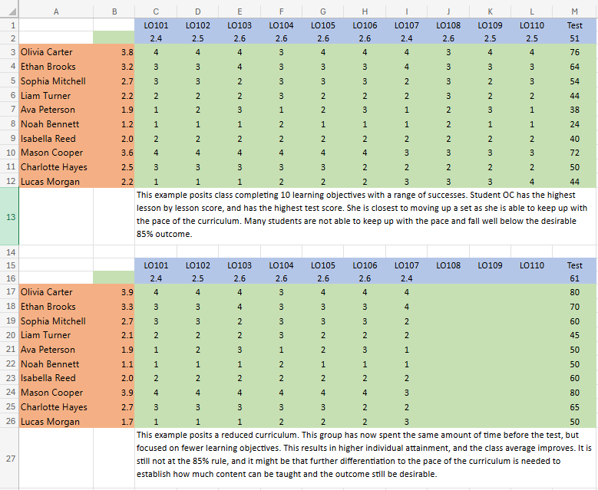
When fewer LOs are undertaken by the class, the pedagogy predicts that the overall grade will increase toward the desirable 85% rule. By reducing the quantity of LOs (the curriculum pace), the overall cognitive load is reduced and the key ingredients of success can be included in outcomes. When students are undertaking more LOs than they can recall under assessment conditions, lesson time was not being used effectively.

Inclusivity
UNESCO explicitly states that inclusive education works to identify and remove barriers to education, covering everything from curriculum to teaching methods. The emphasis is on transforming the education system rather than expecting learners to adapt to it. This perspective is particularly relevant when considering:
- school refusers
- home-educated learners
- multilingual learners
- pupils with disabilities
- pupils at risk of exclusion
In England, the Education Endowment Foundation has become highly influential in promoting curriculum accessibility through high-quality teaching. The "Five-a-Day" approaches are:
- Explicit instruction
- Cognitive and metacognitive strategies
- Scaffolding
- Flexible grouping
- Use of technology
Following the SEND Code of Practice and Ofsted's current thinking, the term adaptive teaching has increasingly replaced differentiation. The core idea is to maintain ambitious curriculum goals for all pupils, but adapt the route through the curriculum. Examples include:
- worked examples
- scaffolded tasks
- visual supports
- sentence stems
- assistive technology
- flexible pacing

